Question 2:

1. Source: A population based simulated annealing algorithm for capacitated vehicle routing problem, İLHAN İLHAN

The writer’s purpose is solving a Capacitated Vehicle Routing Problem using metaheuristic algorithms. Vehicle Routing Problem is identifying the best route to reduce distribution costs and improve the quality of service provided to customers. The writer is using randomly insertion and reversion operators on 23 instances on MATLAB for testing and analyzing with other algorithm.

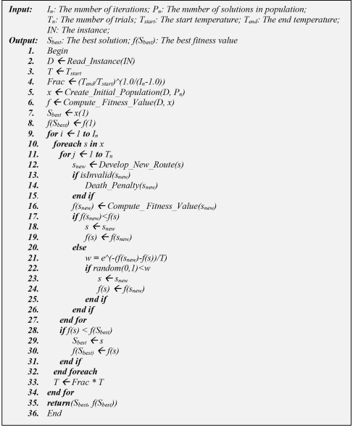

Update Temperature

Update best solution

Store best solution

Create and Evaluate New Solutions

Initialize Fitness Value

Initialize Population

Initialize Temperature

Evaluate New Solutions

Create New Solutions

1. Indicating steps of code is commanded by the writer. I just looked and understand the code.

The code source: <https://yarpiz.com/372/ypap108-vehicle-routing-problem>

In this source, you can find a lot of examples. They are using matlab.

mu = 0.5; % Mutation Rate

sigma = 0.1*(VarMax-VarMin); % Mutation Range (Standard Deviation)

%% Initialization

% Create Empty Structure for Individuals

empty_individual.Position = [];

empty_individual.Cost = [];

% Create Population Array

pop = repmat(empty_individual, nPop, 1);

% Initialize Best Solution

BestSol.Cost = inf;

% Initialize Population

for i = 1:nPop

% Initialize Position

pop(i).Position = unifrnd(VarMin, VarMax, VarSize);

% Evaluation

pop(i).Cost = CostFunction(pop(i).Position);

% Update Best Solution

if pop(i).Cost <= BestSol.Cost

BestSol = pop(i);

end

end

% Array to Hold Best Cost Values

BestCost = zeros(MaxIt, 1);

% Intialize Temp.

T = T0;

%% SA Main Loop

for it = 1:MaxIt

for subit = 1:MaxSubIt

% Create and Evaluate New Solutions

newpop = repmat(empty_individual, nPop, nMove);

for i = 1:nPop

for j = 1:nMove

% Create Neighbor

newpop(i, j).Position = Mutate(pop(i).Position, mu, sigma, VarMin, VarMax);

% Evaluation

newpop(i, j).Cost = CostFunction(newpop(i, j).Position);

end

end

newpop = newpop(:);

% Sort Neighbors

[~, SortOrder] = sort([newpop.Cost]);

newpop = newpop(SortOrder);

for i = 1:nPop

if newpop(i).Cost <= pop(i).Cost

pop(i) = newpop(i);

else

DELTA = (newpop(i).Cost-pop(i).Cost)/pop(i).Cost;

P = exp(-DELTA/T);

if rand <= P

pop(i) = newpop(i);

end

end

% Update Best Solution Ever Found

if pop(i).Cost <= BestSol.Cost

BestSol = pop(i);

end

end

end

% Store Best Cost Ever Found

BestCost(it) = BestSol.Cost;

% Display Iteration Information

disp(['Iteration ' num2str(it) ': Best Cost = ' num2str(BestCost(it))]);

% Update Temp.

T = alpha*T;

sigma = 0.98*sigma;

end

%% Results

figure;

%plot(BestCost, 'LineWidth', 2);

semilogy(BestCost, 'LineWidth', 2);

xlabel('Iteration');

ylabel('Best Cost');

grid on;